HANDS – ON 4
Resolve the conflict during merge
- Verify if master is in clean state.
- Create a branch “GitWork”. Add a file “hello.xml”.
- Update the content of “hello.xml” and observe the status
- Commit the changes to reflect in the branch
- Switch to master.
- Add a file “hello.xml” to the master and add some different content than previous.
- Commit the changes to the master

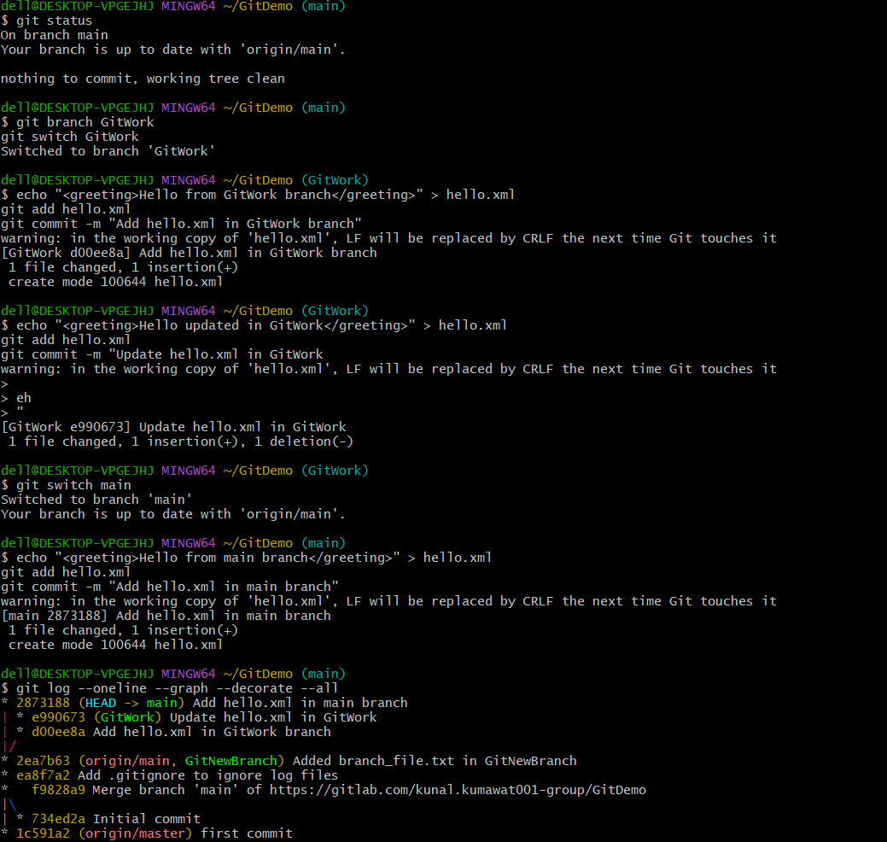
- Observe the log by executing “git log –oneline –graph –decorate –all”
- Check the differences with Git diff tool
- For better visualization, use P4Merge tool to list out all the differences between master and branch
- Merge the bran to the master
- Observe the git mark up.
- Use 3-way merge tool to resolve the conflict
- Commit the changes to the master, once done with conflict
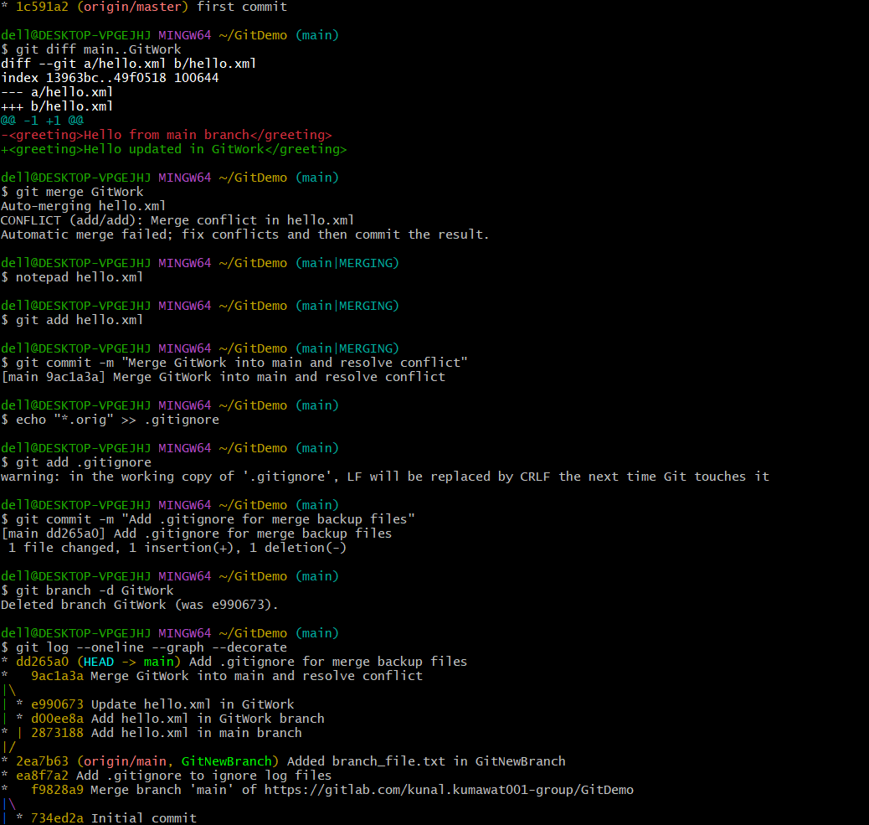

- Observe the git status and add backup file to the .gitignore file.
- Commit the changes to the .gitignore
- List out all the available branches
- Delete the branch, which merge to master.
- Observe the log by executing “git log –oneline –graph –decorate”
